**2. Register Domain AWS Route53**

--- Reference - <https://github.com/stacksimplify/aws-eks-kubernetes-masterclass/tree/master/08-ELB-Application-LoadBalancers/08-04-ALB-Ingress-SSL>

**Introduction**

--- We are going to register a new DNS in AWS Route53

--- We are going to create an SSL certificate

--- Add Annotations related to SSL Certificate in Ingress manifest

--- Deploy the manifests and test

--- Clean-Up

**Pre-requisite - Register a Domain in Route53 (if not exists)**

--- Goto Services -> Route53 -> Registered Domains

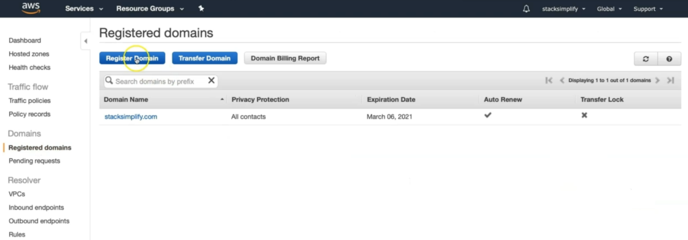

--- Click on Register Domain

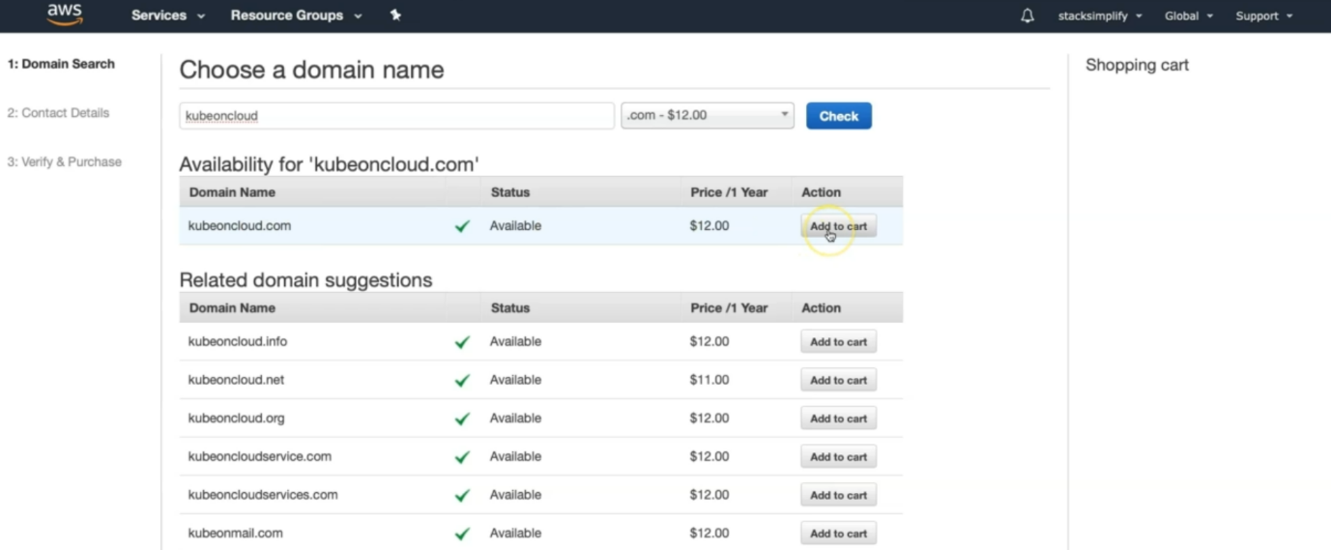

--- Provide desired domain: somedomain.com and click on check (In my case it’s going to be kubeoncloud.com)

--- Click on Add to cart and click on Continue

--- Provide your Contact Details and click on Continue

--- Enable Automatic Renewal

--- Accept Terms and Conditions

--- Click on Complete Order

**DNS register our domain**

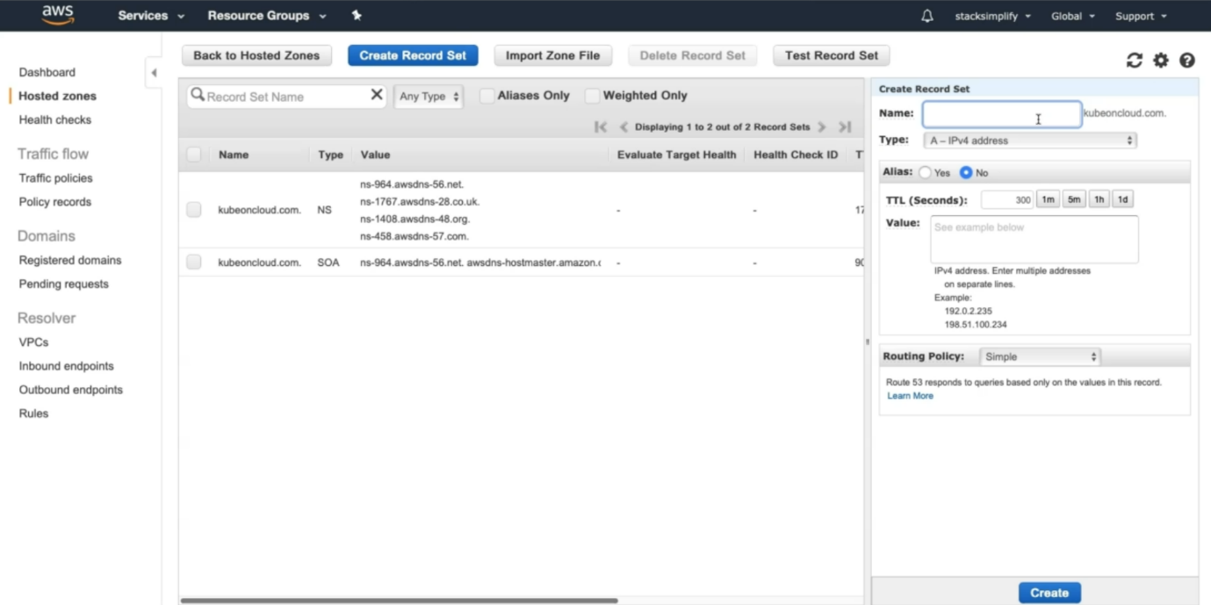

--- click on create record set.

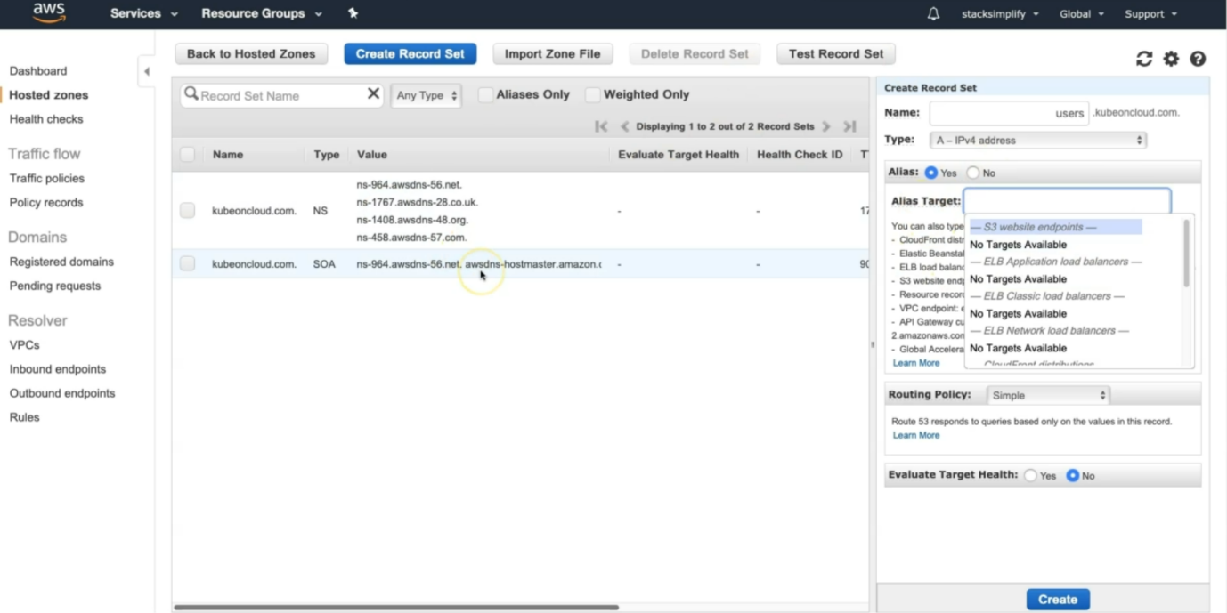

--- inside of name section, you can give the subdomain name. select alias target type as AWS load balancer DNS name.